38.17: a) 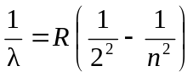 (Balmer series implies final state is n = 2)
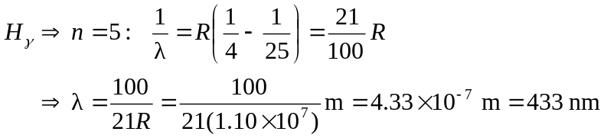
b) 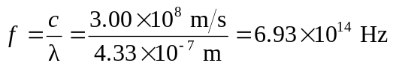
c) 